**Data Structures**

Printing the level of each node of a heap

**Level of a node:**

* the total no of edges between the root node and the current node is called as level of a node.
* Traverse through the tree and while traversing increment the level of the tree

with one in each recursive call of the same function.

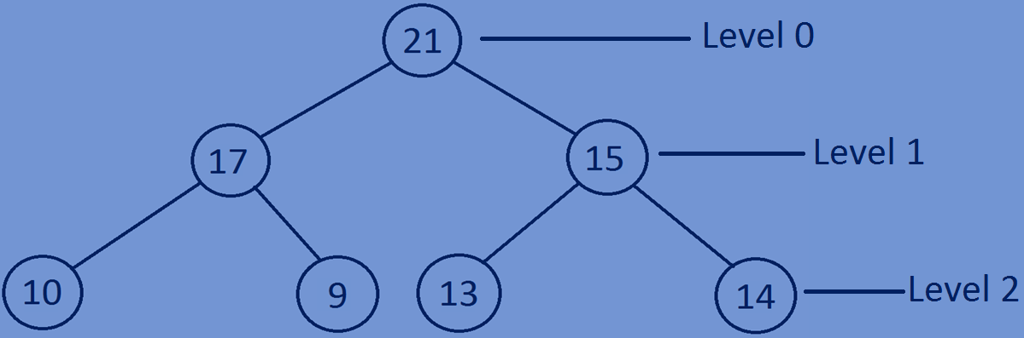

**Printing level of each node:**

* If root is equal to NULL then return -1;
* If root->data is equal to data return the level.
* Else call the function recursively incrementing the level and return the level.

**int levelofnode=callevel(root->left,data,level+1);**

**if(levelofnode!=-1)**

**return levelofnode;**

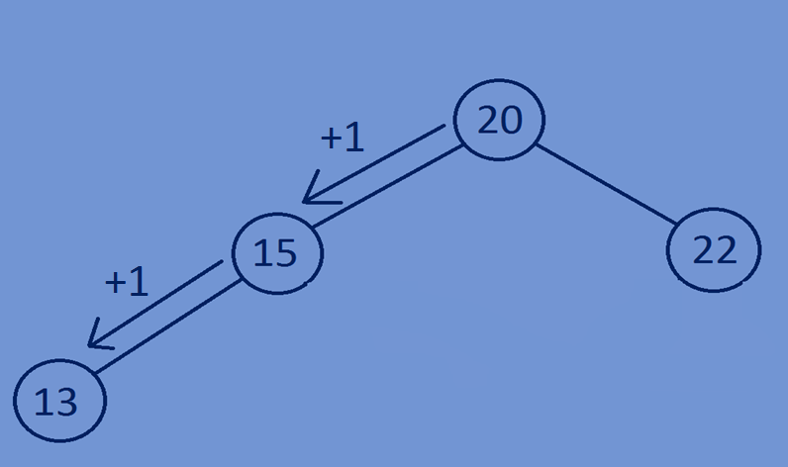 **return callevel(root->right,data,level+1);**

**Function for printing level of each node in a heap:**

//recursive function for finding the level of a node   
**int** callevel(Bstree *root,**int** data,**int** level){  
 **if**(root==NULL){  
 **return** -1;  
 }  
 **if**(root->data==data){  
 **return** level;  
 }  
 **int** levelofnode=callevel(root->left,data,level+1);  
 **if**(levelofnode!=-1){  
 **return** levelofnode;  
 }  
 **return** callevel(root->right,data,level+1);  
}

**Whole program:**

#include<stdio.h>  
#include<stdlib.h>  
//creating a node  
**typedef struct** Bstree{  
 **int** data;  
 **struct** Bstree *left;  
 **struct** Bstree *right;  
}Bstree;  
//creating new nodes  
Bstree *createnewnode(**int** data){  
 Bstree *newnode=(Bstree*)malloc(**sizeof**(Bstree));  
 newnode->data=data;  
 newnode->left=NULL;  
 newnode->right=NULL;  
 **return** newnode;  
}  
//swaping data of two nodes  
**void** swapData(Bstree *temp1,Bstree *temp2){  
 **int** temp3;  
 temp3=temp1->data;  
 temp1->data=temp2->data;  
 temp2->data=temp3;  
}  
//function for bubbling of data in root node  
**void** bubbleDown(Bstree *node){  
 Bstree *smallestNode;  
 **if**(node==NULL){  
 **return**;  
 }  
 **if**(node->left!=NULL && node->left->data < node->data){  
 smallestNode=node->left;  
 swapData(node,smallestNode);  
 bubbleDown(smallestNode);  
 }  
 **if**(node->right!=NULL && node->right->data < node->data){  
 smallestNode=node->right;  
 swapData(node,smallestNode);  
 bubbleDown(smallestNode);  
 }  
  
}  
//function for heapifying a complete binary tree  
**void** heapifyTree(Bstree *root){  
 **if** (root == NULL) {  
 **return**;  
 }  
  
 heapifyTree(root->left);  
 heapifyTree(root->right);  
  
 bubbleDown(root);  
}  
//recursive function for finding the level of a node  
**int** callevel(Bstree *root,**int** data,**int** level){  
 **if**(root==NULL){  
 **return** -1;  
 }  
 **if**(root->data==data){  
 **return** level;  
 }  
 **int** levelofnode=callevel(root->left,data,level+1);  
 **if**(levelofnode!=-1){  
 **return** levelofnode;  
 }  
 **return** callevel(root->right,data,level+1);  
}  
//print all the nodes of a tree in preorder fashion  
**void** preorder(Bstree *root,Bstree *tree){  
 **if**(root){  
 printf("%d-%d ",root->data,callevel(tree,root->data,0));  
 preorder(root->left,tree);  
 preorder(root->right,tree);  
 }  
}  
//main function  
**int** main(){  
 Bstree *tree=NULL;  
 tree=createnewnode(8);  
 tree->left=createnewnode(10);  
 tree->right=createnewnode(9);  
 tree->left->left=createnewnode(2);  
 tree->left->right=createnewnode(7);  
 tree->right->left=createnewnode(1);  
 tree->right->right=createnewnode(3);  
 preorder(tree,tree);printf("\n");  
 heapifyTree(tree);  
 preorder(tree,tree);printf("\n");  
 **return** 0;  
}

**Output:**

8-0 10-1 2-2 7-2 9-1 1-2 3-2

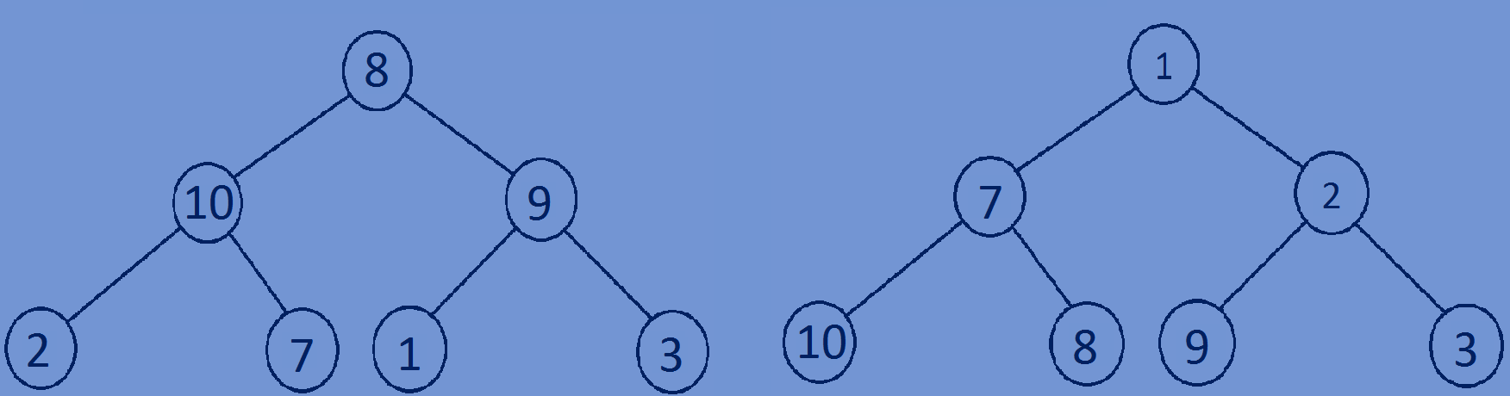1-0 7-1 10-2 8-2 2-1 9-2 3-2